1. 这件事情十年前发生，很多细节已经含糊不清了。
2. “团结”->合作？
3. “早晚总有一天” –>总有一天
4. “产生”🡪引发？
5. “传来”->传来时
6. “保证”->维持
7. “讲卫生，懂礼貌”->?
8. “电光闪闪”—>“光电闪闪”
9. “在会议上”——>会议上
10. “的作者是著名的作家”->”是著名的作家”

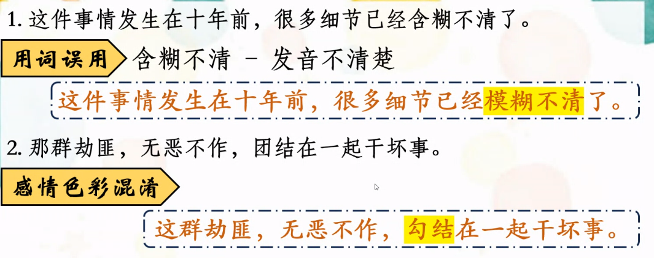

第八顺逆倒翻

古典诗词